**Overview:**

This R script calculates the Euclidean distances between neighboring immunopuncta. Specifically, it calculates the distance between a given immunopunctum and its closest neighboring immunopunctum. These data (along with immunopuncta IDs) are exported as an Excel file (.xlsx format) for further analysis in R. This protocol requires RStudio, Excel, and Imaris (or equivalent software for calculating x,y,z coordinates for immunpuncta). Separate instructions on using imaris can be found at <http://thepyottlab.com/euclidean-distances/>.

**Please cite:**

Sadeghi SG, Pyott SJ, Yu Z, Glowatzki E. 2014. Glutamatergic signaling at the vestibular hair cell calyx synapse. J Neurosci. 34(44):14536-50. PMID: 25355208.

**Additional references:**

Ye Z, Goutman JD, Pyott SJ, Glowatzki E. 2017. mGluR1 enhances efferent inhibition of inner hair cells in the developing rat cochlea. J Physiol. 595(11):3483-3495. PMID: 28211069.

Barone CM, Douma S, Reijntjes DOJ, Browe BM, Köppl C, Klump G, Park TJ, Pyott SJ. 2019. Altered cochlear innervation in developing and mature naked and Damaraland mole rats. J Comp Neurol. 527(14):2302-2316. PMID: 30861124.

**Procedure:**

1. In Imaris, import files and use the “spots” function to identify immunopuncta for each channel and calculate their center point x,y,z coordinates. (Instructions for using Imaris are also available from the Pyott Lab at <http://thepyottlab.com/researchers/>.)
2. In Imaris, export x,y,z coordinates and immunopuntca IDs for each immunolabel from Imaris to Excel.
3. Export Excel files directly from Imaris in .xlsx format.
4. 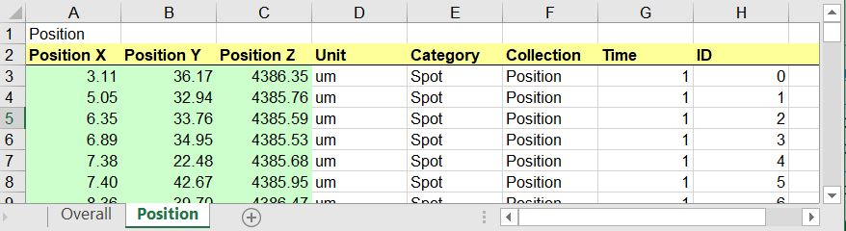Export the single “detailed” “datasheet using the single floppy disk icon. The file should contain the information organized as shown in the figure below.
5. Rename file names so that they are in the form “immunolabel_subjectID.xlsx” and contain an immunolabel identifier (e.g., CTBP2 or synapsin) as well as a subject ID separated by an underscore. File names must be identical except for the immunolabel. Example:
6. Before starting analysis, create an empty folder and add the Euclid_script.R file and data files described above.
7. Double click on Euclid_script.R to open the file in RStudio.
8. Follow the instructions in the script. The following steps are essential:
   1. Add all .xlsx data files (with the layout described in Step 2) to the folder created in Step 3.
   2. Set the working directory in R to the folder created in step 3.
   3. Make sure the “readxl” package is installed and loaded in RStudio.
   4. Set the working directory in R to the folder created in step 3.
   5. Set immunolabel identifiers (e.g., “CTBP2” and “Synapsin”).
   6. Run the script by clicking on the “Source” button.
9. 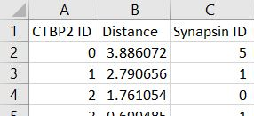Euclidean distances will be calculated and compiled into a new file (.csv format) titled with the original Subject ID and appended with “_results” (i.e., subjectID_results.csv”). The new file will contain the information organized as shown in the figure below.